EXPT NO: 1 | BUILDING AND TRAINING A SIMPLE ARTIFICIAL NEURAL NETWORK (ANN) FOR REGRESSION AND CLASSIFICATION
DATE:

PRE-LAB QUESTIONS (PROVIDE BRIEF ANSWERS TO THE FOLLOWING QUESTIONS)

- What is an Artificial Neural Network (ANN)?

An Artificial Neural Network (ANN) is a machine learning model inspired by the human brain. It consists of interconnected neurons organized into layers that learn patterns from data to make predictions or classifications.

- What are the functions of the input, hidden, and output layers in an ANN?

  - Input Layer: Receives the input features from the dataset.
  - Hidden Layer: Processes the input using weights, biases, and activation functions to learn complex patterns.
  - Output Layer: Produces the final prediction or classification result.

- Why is feature scaling important before training an ANN?

Feature scaling ensures that all input features are on a similar scale, which helps the ANN converge faster, improves training stability, and prevents features with larger values from dominating the learning process.

- Differentiate between regression and classification problems with examples.

Regression | Classification
Predicts continuous numerical values. | Predicts discrete class labels.
Example: Predicting house prices. | Example: Detecting whether a tumor is benign or malignant.

- What is the role of the activation function in a neural network?

The activation function introduces non-linearity into the network, enabling it to learn complex relationships and make accurate predictions.

AIM
To understand the implementation of Artificial Neural Networks (ANN) using TensorFlow and evaluate their performance on regression and classification problems.

SOFTWARE REQUIREMENTS
- Python 3.x
- Google Colab / Jupyter Notebook
- TensorFlow 2.x
- NumPy
- Pandas
- Matplotlib
- Scikit-learn

LEARNING OBJECTIVES
After completing this experiment, students will be able to:
- Understand the architecture of an Artificial Neural Network.
- Build an ANN for regression problems.
- Build an ANN for classification problems.
- Train and evaluate neural network models.
- Compare different evaluation metrics used for regression and classification.

Task A – ANN FOR REGRESSION
DATASET: California Housing Dataset
SOURCE: Scikit-learn
DESCRIPTION
- Samples: 20,640
- Features: 8
- Target: Median House Value

FEATURES
Feature | Description
MedInc | Median Income
HouseAge | House Age
AveRooms | Average Rooms
AveBedrms | Average Bedrooms
Population | Population
AveOccup | Average Occupancy
Latitude | Latitude
Longitude | Longitude

ALGORITHM
- Import libraries.
- Load California Housing dataset.
- Split into training and testing sets.
- Standardize the features.
- Build ANN model.
- Compile the model.
- Train the model.
- Predict house prices.
- Evaluate using:
  - MSE
  - MAE
  - RMSE

Code:

# EXPERIMENT 1 - TASK A
# ANN FOR REGRESSION
# Roll No: 24BAD105

# Step 1: Import Libraries
import numpy as np
import tensorflow as tf
import matplotlib.pyplot as plt

from sklearn.datasets import fetch_california_housing
from sklearn.model_selection import train_test_split
from sklearn.preprocessing import StandardScaler
from sklearn.metrics import mean_squared_error, mean_absolute_error

# Step 2: Load Dataset
housing = fetch_california_housing()

X = housing.data
y = housing.target

print("Dataset Loaded Successfully")
print("Features Shape :", X.shape)
print("Target Shape :", y.shape)

# Step 3: Split Dataset
X_train, X_test, y_train, y_test = train_test_split(
X, y,
test_size=0.2,
random_state=42
)

# Step 4: Feature Scaling
scaler = StandardScaler()

X_train = scaler.fit_transform(X_train)
X_test = scaler.transform(X_test)

# Step 5: Build ANN Model
model = tf.keras.Sequential([
tf.keras.layers.Dense(64, activation='relu'),
tf.keras.layers.Dense(32, activation='relu'),
tf.keras.layers.Dense(1)
])

# Step 6: Compile Model
model.compile(
optimizer='adam',
loss='mse',
metrics=['mae']
)

# Step 7: Train Model
history = model.fit(
X_train,
y_train,
epochs=50,
batch_size=32,
validation_split=0.2,
verbose=1
)

# Step 8: Prediction
y_pred = model.predict(X_test)

# Step 9: Evaluation
mse = mean_squared_error(y_test, y_pred)
mae = mean_absolute_error(y_test, y_pred)
rmse = np.sqrt(mse)

print("\n========== Regression Results ==========")
print("Mean Squared Error :", mse)
print("Mean Absolute Error :", mae)
print("Root Mean Squared Error :", rmse)

# Step 10: Plot Loss Graph
plt.figure(figsize=(8,5))
plt.plot(history.history['loss'], label='Training Loss')
plt.plot(history.history['val_loss'], label='Validation Loss')
plt.title("ANN Regression Loss")
plt.xlabel("Epoch")
plt.ylabel("Loss")
plt.legend()
plt.show()

Screenshot: (Code)

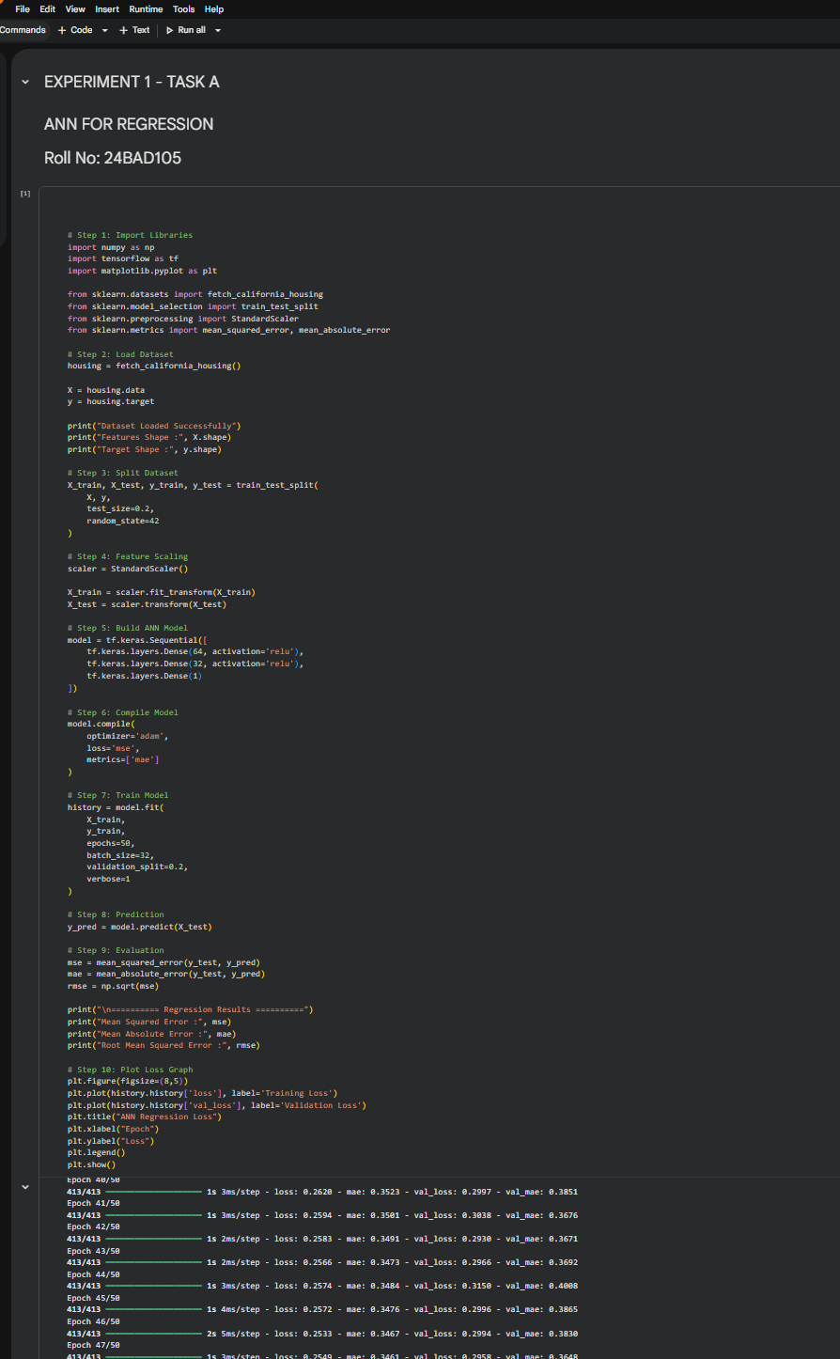

Screenshot: (Output)

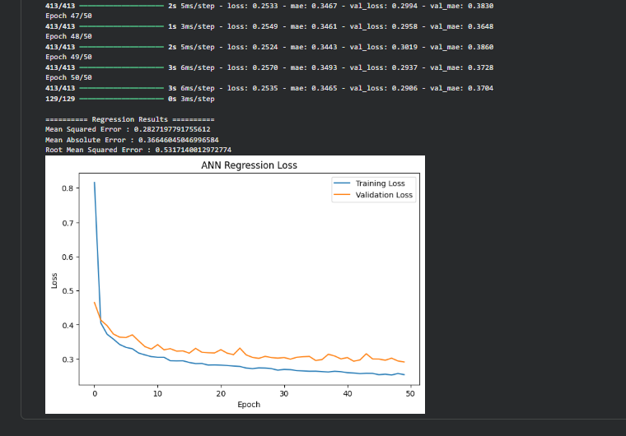

Task B – ANN FOR CLASSIFICATION
DATASET: Breast Cancer Wisconsin Dataset
SOURCE: Scikit-learn
DESCRIPTION
- Samples: 569
- Features: 30
- Classes:
  - Malignant
  - Benign

ALGORITHM
- Import libraries.
- Load Breast Cancer dataset.
- Split dataset.
- Standardize features.
- Design ANN.
- Compile model.
- Train model.
- Predict labels.
- Evaluate:
  - Accuracy
  - Precision
  - Recall
  - F1-score
  - Confusion Matrix

Code:

# EXPERIMENT 1 - TASK B
# ANN FOR CLASSIFICATION
# Roll No: 24BAD105

# Step 1: Import Libraries
import numpy as np
import tensorflow as tf
import matplotlib.pyplot as plt

from sklearn.datasets import load_breast_cancer
from sklearn.model_selection import train_test_split
from sklearn.preprocessing import StandardScaler

from sklearn.metrics import accuracy_score
from sklearn.metrics import precision_score
from sklearn.metrics import recall_score
from sklearn.metrics import f1_score
from sklearn.metrics import confusion_matrix

# Step 2: Load Dataset
data = load_breast_cancer()

X = data.data
y = data.target

print("Dataset Loaded Successfully")
print("Features Shape :", X.shape)
print("Target Shape :", y.shape)

# Step 3: Split Dataset
X_train, X_test, y_train, y_test = train_test_split(
X,
y,
test_size=0.2,
random_state=42
)

# Step 4: Feature Scaling
scaler = StandardScaler()

X_train = scaler.fit_transform(X_train)
X_test = scaler.transform(X_test)

# Step 5: Build ANN Model
classifier = tf.keras.Sequential([
tf.keras.layers.Dense(32, activation='relu'),
tf.keras.layers.Dense(16, activation='relu'),
tf.keras.layers.Dense(1, activation='sigmoid')
])

# Step 6: Compile Model
classifier.compile(
optimizer='adam',
loss='binary_crossentropy',
metrics=['accuracy']
)

# Step 7: Train Model
history = classifier.fit(
X_train,
y_train,
epochs=30,
batch_size=32,
validation_split=0.2,
verbose=1
)

# Step 8: Prediction
y_pred = classifier.predict(X_test)
y_pred = (y_pred > 0.5).astype(int)

# Step 9: Evaluation
accuracy = accuracy_score(y_test, y_pred)
precision = precision_score(y_test, y_pred)
recall = recall_score(y_test, y_pred)
f1 = f1_score(y_test, y_pred)
cm = confusion_matrix(y_test, y_pred)

print("\n========== Classification Results ==========")
print("Accuracy :", accuracy)
print("Precision :", precision)
print("Recall :", recall)
print("F1 Score :", f1)

print("\nConfusion Matrix")
print(cm)

# Step 10: Plot Accuracy Graph
plt.figure(figsize=(8,5))
plt.plot(history.history['accuracy'], label='Training Accuracy')
plt.plot(history.history['val_accuracy'], label='Validation Accuracy')
plt.title("ANN Classification Accuracy")
plt.xlabel("Epoch")
plt.ylabel("Accuracy")
plt.legend()
plt.show()

Screenshot: (Code)

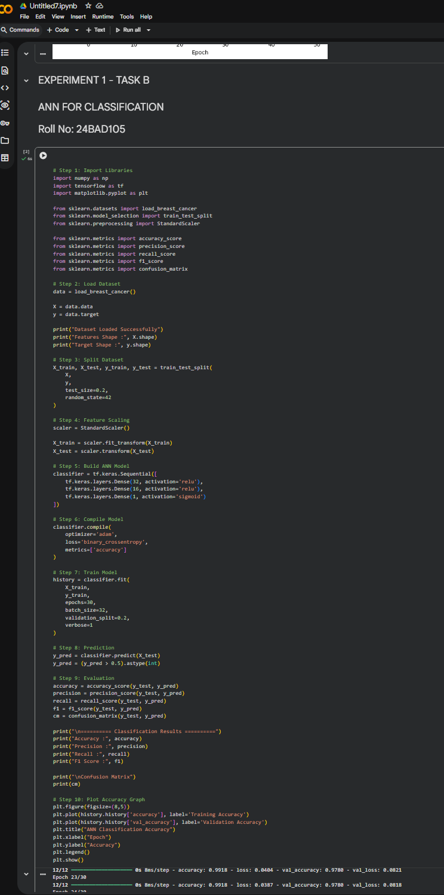

Screenshot: (Output)

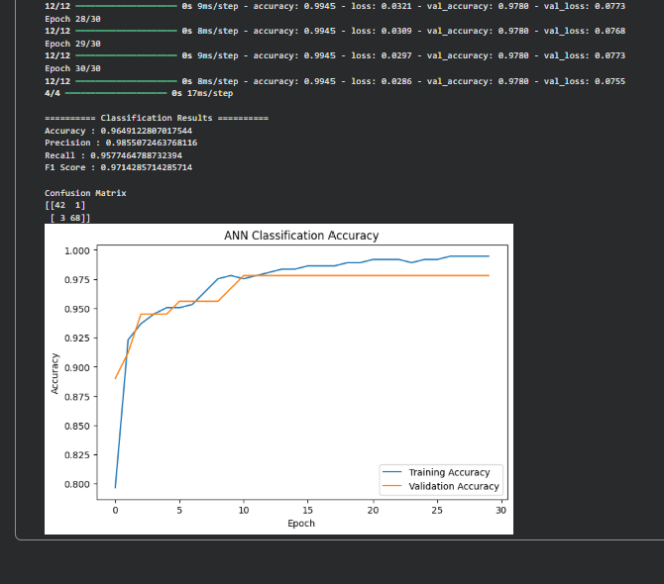

POST-LAB QUESTIONS (PROVIDE BRIEF ANSWERS TO THE FOLLOWING QUESTIONS)

- Why is the Adam optimizer commonly used in ANN training?

The Adam optimizer combines the advantages of Momentum and RMSProp. It automatically adjusts the learning rate, trains the model efficiently, converges quickly, and performs well on most deep learning problems.

- Compare Mean Squared Error (MSE) and Mean Absolute Error (MAE). Which metric is more sensitive to outliers?

- MSE: Calculates the average of squared errors, giving more weight to large errors.
- MAE: Calculates the average of absolute errors, treating all errors equally.

MSE is more sensitive to outliers because the errors are squared.

- Why is the sigmoid activation function used in binary classification?

The sigmoid activation function converts the output into a probability value between 0 and 1, making it suitable for binary classification tasks.

- How does increasing the number of hidden layers affect the performance of an ANN?

Increasing hidden layers allows the ANN to learn more complex patterns and improve accuracy. However, too many hidden layers may increase training time, computational cost, and the risk of overfitting.

- Compare the evaluation metrics used for regression and classification tasks. Why are different metrics required for these problems?

Regression | Classification
MSE, MAE, RMSE | Accuracy, Precision, Recall, F1-score, Confusion Matrix

Regression metrics measure the difference between predicted and actual numerical values, whereas classification metrics evaluate how well the model predicts class labels. Different metrics are required because the outputs of regression and classification are fundamentally different.

ASSESSMENT
Description | Max Marks | Marks Awarded
Pre Lab Exercise | 5
In Lab Exercise | 10
Post Lab Exercise | 5
Viva | 10
Total | 30
Faculty Signature

